**Assignment**

**Date: 18/04/2022**

**Submission Date:**

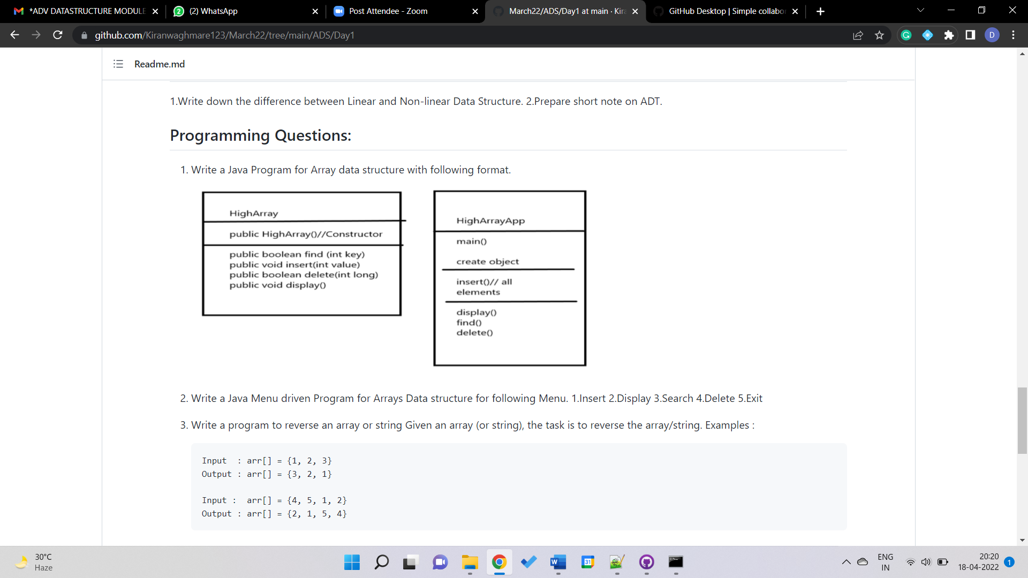

import java.util.*;

class HighArray{

static int n=0;

private int a[]=new int[100];

HighArray(){

System.out.println("A new HighArray object is created!");

}

public void insert(int... arr){

for(int x:arr){

a[n++]=x;

}

}

public int find(int key){

for(int i=0; i<n; i++){

if(a[i]==key)

return i;

}

return -1;

}

public void display(){

for(int i=0; i<n; i++){

System.out.print(a[i]+" ");

}

}

public boolean delete (int key){

int x=this.find(key);

if(x==-1){

return false;

}else{

for(int i=x; i<n; i++)

a[i]=a[i+1];

n--;

return true;

}

}

static void menu(){

System.out.println("================================================");

System.out.println("1. Insert Elements \n2. Find Element");

System.out.println("3. Display Elements \n4. Delete Element");

System.out.print("Please enter your choice: ");

}

}

class Test{

public static void main(String args[]){

Scanner sc=new Scanner(System.in);

HighArray arr=new HighArray();

int n, key;

char choice='y';

while (choice=='y' || choice=='Y'){

HighArray.menu();

n=sc.nextInt();

switch(n){

case 1: System.out.print("Enter the elements to insert: ");

sc.nextLine();

String s=sc.nextLine();

String ss[]=s.split("[^0-9]+");

int ele[]=new int[ss.length];

for(int i=0;i<ss.length; i++)

ele[i]=Integer.valueOf(ss[i]);

arr.insert(ele);

break;

case 2: System.out.print("Enter the elements to find: ");

key=sc.nextInt();

int index=arr.find(key);

if(index==-1){

System.out.println(key+" not present in the array");

}else{

System.out.println(key+" found at index number '"+index+"'");

}

break;

case 3: arr.display();

break;

case 4: System.out.print("Enter the elements to delete: ");

key=sc.nextInt();

boolean status=arr.delete(key);

if(status==false)

System.out.println(key+" not present in the array to delete");

break;

default: System.out.println("You entered wrong choice!!");

}

System.out.print("Do you wish to continue (y/n): ");

choice=sc.next().charAt(0);

}

}

}

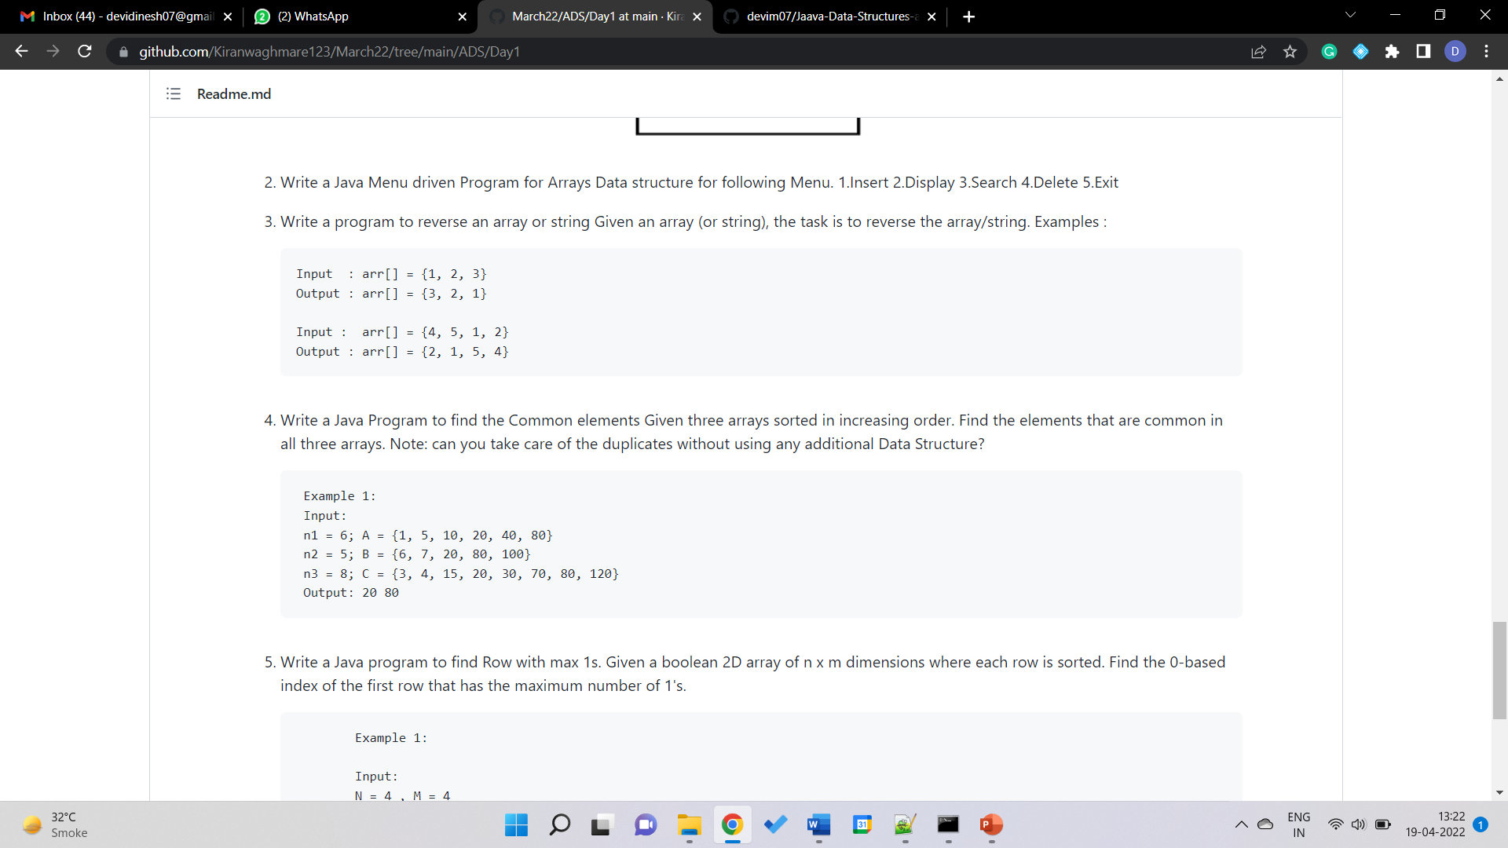 (Reverse Array or String 1)

import java.util.*;

class Test{

public static void main(String args[]){

Scanner sc= new Scanner(System.in);

System.out.print("Would you like to enter (1) array or (2) string? ");

int k=sc.nextInt();

sc.nextLine();

switch(k){

case 1:

System.out.print("Enter the array elements: ");

String line1=sc.nextLine();

String iarr[]=line1.split("[^0-9]+");

int n[]=new int[iarr.length];

for(int i=0; i<iarr.length; i++)

n[i]=Integer.valueOf(iarr[i]);

System.out.print("The given array in reverse order: ");

for(int i=n.length-1; i>=0; i--)

System.out.print(n[i]+" ");

break;

case 2:

System.out.print("Enter the string: ");

String line2=sc.nextLine();

char sarr[]=line2.toCharArray();

System.out.print("The given string in reverse order: ");

for(int i=sarr.length-1; i>=0; i--)

System.out.print(sarr[i]);

break;

default:System.out.println("Your input is wrong!!");

}

}

}



import java.util.*;

class MyArray{

static int n=0;

static int com[]=new int[20];

public void insert(int x){

com[n++]=x;

}

public void find(int key, int... arr){

for(int i=0; i<arr.length; i++){

if(arr[i]==key)

this.insert(key);

}

}

public void findCom(int key, int... arr){

boolean found=false;

for(int i=0; i<arr.length; i++){

if(arr[i]==key)

found=true;

}

if(found==false)

this.delete(key);

}

public void delete (int key){

for(int i=0; i<n; i++)

if(com[i]>=key)

com[i]=com[i+1];

n--;

}

}

class Test{

public static void main(String args[]){

Scanner sc= new Scanner(System.in);

MyArray marr=new MyArray();

int m,i;

System.out.print("No. of elements in 1st array: ");

m=sc.nextInt();

int arr1[]=new int[m];

System.out.print("Enter the elements in 1st array: ");

for(i=0; i<m; i++)

arr1[i]=sc.nextInt();

System.out.print("No. of elements in 2nd array: ");

m=sc.nextInt();

int arr2[]=new int[m];

System.out.print("Enter the elements in 2nd array: ");

for(i=0; i<m; i++)

arr2[i]=sc.nextInt();

System.out.print("No. of elements in 3rd array: ");

m=sc.nextInt();

int arr3[]=new int[m];

System.out.print("Enter the elements in 3rd array: ");

for(i=0; i<m; i++)

arr3[i]=sc.nextInt();

for(i=0; i<arr1.length; i++)

marr.find(arr1[i], arr2);

for(i=0; i<MyArray.n; i++)

marr.findCom(MyArray.com[i],arr3);

System.out.print("The common elements are: ");

for(i=0; i<MyArray.n; i++)

System.out.print(MyArray.com[i]+" ");

}

}



For any number of arrays

()

import java.util.*;

class MyArray{

static int n=0;

static int com[]=new int[50];

public void insert(int x){

com[n++]=x;

}

public void find(int key, int arr[]){

for(int i=0; i<arr.length; i++){

if(arr[i]==key)

this.insert(key);

}

}

public void findCom(int key, int arr[]){

boolean found=false;

for(int i=0; i<arr.length; i++){

if(arr[i]==key)

found=true;

}

if(found==false)

this.delete(key);

}

public void delete (int key){

for(int i=0; i<n; i++)

if(com[i]>=key)

com[i]=com[i+1];

n--;

}

}

class Test{

public static void main(String args[]){

Scanner sc= new Scanner(System.in);

MyArray marr=new MyArray();

int m,i;

System.out.print("Enter the number of arrays: ");

m=sc.nextInt();

int arr[][]=new int[m][];

for(i=0; i<m; i++){

System.out.print("Enter the number of elements in array "+(i+1)+": ");

int x=sc.nextInt();

arr[i]=new int[x];

for(int j=0; j<x; j++){

arr[i][j]=sc.nextInt();

}

}

for(i=0; i<arr[0].length; i++)

marr.find(arr[0][i], arr[1]);

for(i=2; i<m; i++){

for(int j=0; j<MyArray.n; j++)

marr.findCom(MyArray.com[j],arr[i]);

}

System.out.print("The common elements are: ");

for(i=0; i<MyArray.n; i++)

System.out.print(MyArray.com[i]+" ");

}

}

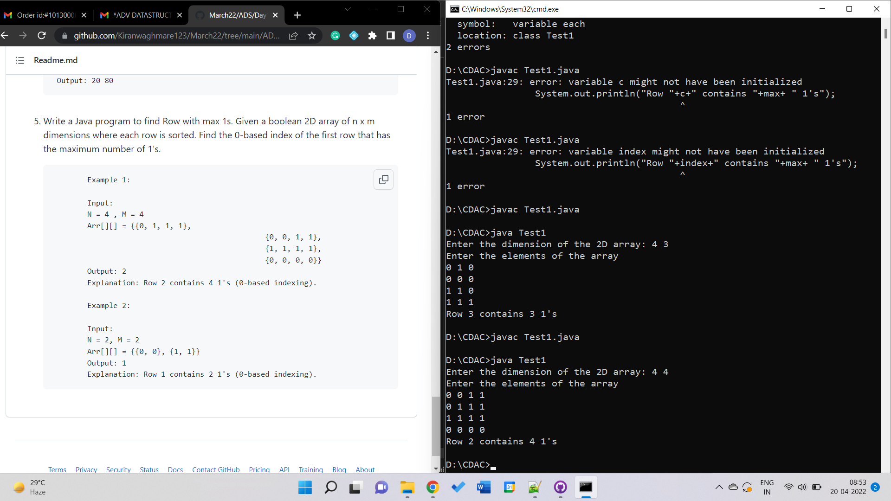

(Row in 2d Array containing maximum number of 1's)

import java.util.*;

class Test1{

public static void main(String args[]){

Scanner sc=new Scanner(System.in);

System.out.print("Enter the dimension of the 2D array: ");

int r=sc.nextInt(), cl=sc.nextInt();

int arr[][]=new int[r][cl];

int i,j, c, count[]=new int[r];

System.out.println("Enter the elements of the array");

for(i=0; i<r; i++){

c=0;

for(j=0; j<cl; j++){

arr[i][j]=sc.nextInt();

if (arr[i][j]==1)

c++;

}

count[i]=c;

}

int max=0, index=0;

for(i=0; i<r; i++){

if(max<count[i]){

max=count[i];

index=i;

}

}

System.out.println("Row "+index+" contains "+max+ " 1's");

}

}